Satellite orbit
Selecting an orbit for a telescope mission will take into account many different factors. From an observing point of view, an appropriate Observing Fraction is needed. In terms of cost, a higher altitude will mean a more expensive Ground Control cost. Some orbits have additional requirements, such as a relay satellite or the ability to safely de-orbit the mission.

Orbit Selection | Orbit Altitude | Orbit Period | Observing Fraction | Ambient Temperature
Low Earth Orbit | <1000km | 90 minutes | 50% | 400K
High Earth Orbit | >1000km | 100 minutes | 50% | 300K
Sun-Synchronous Orbit | <1000km | 90 minutes | 100% | 400K
Geostationary Orbit | 36,000km | 24 hours | 50% | 300K
Earth-Trailing | 10,000,000 km | 370 days | 100% | 300K
Earth-Moon L2 | 400,000 km | 27 days | 50% | 300K
Earth-Sun L2 | 1,500,000 km | 365 days | 100% | 300K

The period of an orbit depends on the mass of the body it is orbiting and the distance from its centre.
The gravitational pull from the central object is given by Newton’s law of gravity:
$$F=\frac{GMm}{r^{2}}$$
Where G is Newton’s gravitational constant (6.67x10^{–11} N m² kg⁻²), M is the mass of the central object (e.g. the Earth, m is the mass of the orbiting object (e.g. the satellite), and r is the distance from the centre of each.
Assuming the orbit is circular, this gravitational force acts as a centripetal force, which is related to the velocity, v, of the orbiting object by:
$$F=\frac{mv^{2}}{r}$$
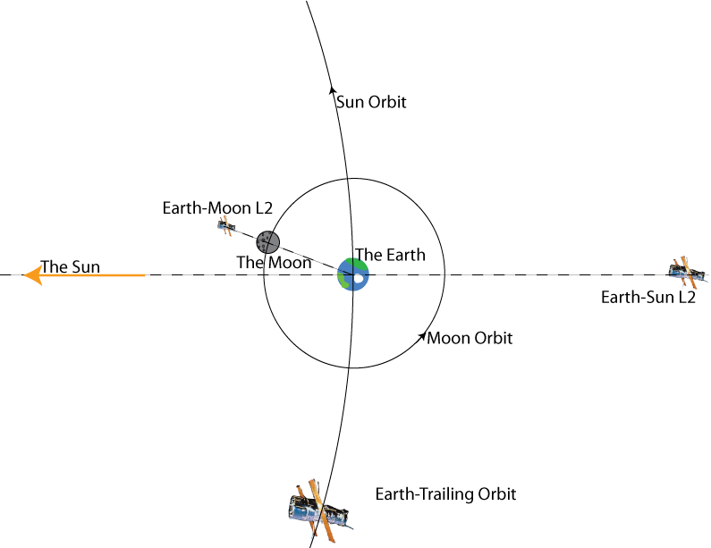
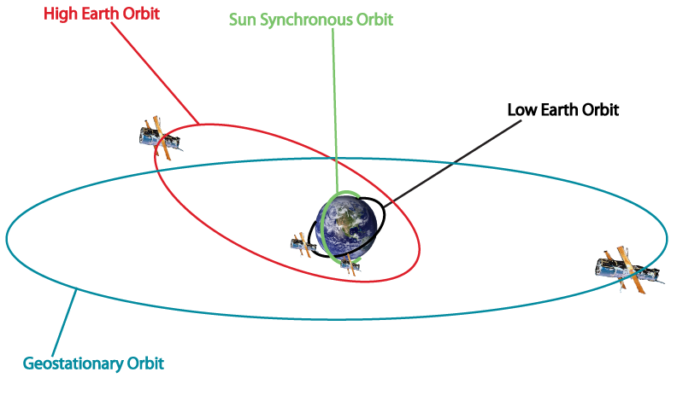

Schematic diagrams of the available orbit selections

Questions

- A satellite in low Earth orbit is typically 300 km above the surface. Use the equations above to calculate its speed
[The radius of the Earth is approximately 6500 km. The mass of the Earth is approximately 6x10²⁴ kg]

- Use the two equations above to show that the relationship between the period and radius of a satellite’s orbit around the Earth is given by the following equation
$$T=\frac{2πr^{3/2}}{\sqrt{GM}}$$

- What altitude would a geostationary satellite orbit at?

- Calculate the velocity of the Earth’s surface at the equator as it spins on its axis. Is this faster or slower than a satellite in low-Earth orbit?

- In which direction does the Earth’s surface move as it rotates?

